PROGRAM TITLE
FINANCE OPERATIONS
PROCESS TITLE
Check Requests and Disbursements

- SCOPE

This policies and procedures manual establishes policies, systems, procedures and controls on check requests and disbursements. All duties and responsibilities stated in this manual are not exclusive to the personnel’s designated responsibilities in this process title.

- OBJECTIVES

- To ensure that disbursements are properly authorized, supported and recorded.
- To identify transactions requiring the preparation of Request for Payment (RFP).
- To ensure that proper documentation is established in the check disbursements process.
- To clearly define the duties and responsibilities of all personnel involved in this process title.

- PERSONNEL INVOLVED

  - Requesting Personnel

    - Prepares the RFP with supporting documents.
    - Forwards the duly filled-out RFP with supporting documents to the Accounting Staff for processing for disbursement.
    - Receives the check from the disbursing officer and acknowledges receipt of check by signing the check voucher.

  - Accounting Staff

    - Receives the RFP with supporting documents from the requesting personnel and sends the same to the appropriate authorized signatories for verification and approval.
    - Prepares the following documents:
- Check Voucher
- Check
- Journal Voucher
- Debit Advice

    - Forwards the check voucher and/or journal voucher to the Accounting Manager for verification. After verification, forwards duly verified check voucher/journal voucher to the President for approval.
    - Forwards printed copy of duly approved check voucher and/or journal voucher, together with duly filled-out but unsigned Check and/or Debit Advice, to Disbursing Officer for payment.
    - Receives duly acknowledged check voucher with attachments from Disbursing Officer.
    - Files the check vouchers and journal voucher accordingly.

  - Disbursing Officer

    - Receives duly approved check voucher and/or journal voucher from the Accounting Staff.
    - Forwards check and/or debit advice to appointed signatories.
    - Prepares the deposit slip on check for deposit to payee’s account.
    - Deposits check to payee’s bank account.
    - Submits Debit Advice to payee’s bank account.
    - Inform payee of direct deposit and/or bank transfer.
    - Checks the identification the payee or supplier’s authorized representative.
    - Requires the payee or authorized representative to acknowledge receipt of check by affixing his/her signature in the Check Voucher.
    - Forwards duly received Check Voucher to the Accounting Staff for filing.

  - Accounting Manager

Verifies the following:
- Check Voucher
- Journal Voucher

  - President and Other Authorized Approving Officer

Approves the following documents:
- Check Voucher
- Journal Voucher
- Check
- Debit Advice (Bank Transfer Form)
- ACCOUNTS

Account Code | Account Title | Account Description
000-00-00-000-0000-7199-7902 | Accounts Payable - Clearing | This account is debited when supporting documents for purchases are completely forwarded to the Accounting Department.
000-00-00-000-0000-1102-1181 | Advances to Supplies | This account is debited when advance payments are made to suppliers. This is credited upon preparation of the APV for the receipt of complete documents
000-00-00-000-0000-2121-2000 | Trade Payables | This account is credited when supporting documents for purchases are completely forwarded to the Accounting Department. This account is debited upon payment trade payables.
 | Cash in Bank | The appropriate cash account is credited upon payment of trade payables.

- JOURNAL ENTRIES

  - To record receipt of complete documents from warehouse department for purchases on account

Account Code |  | Account Title |  | Dr. | Cr.
000-00-00-000-0000-7199-7902 |  | Accounts Payable – Clearing |  | xx
000-00-00-000-0000-2121-2000 |  |  | Trade Payables |  | xx
 |  | #

  - To record receipt of documents from warehouse department for purchases with advance payments

Account Code |  | Account Title |  | Dr. | Cr.
000-00-00-000-0000-7199-7902 |  | Accounts Payable – Clearing |  | xx
000-00-00-000-0000-1102-1181 |  |  | Advances to Supplies |  | xx
 |  | #

  - To record advance payment of procured materials and supplies

Account Code |  | Account Title |  | Dr. | Cr.
000-00-00-000-0000-1102-1181 |  | Advances to Supplies |  | xx
xxx |  |  | Appropriate Cash Account |  | xx
 |  | #

  - To record payment of trade payables

Account Code |  | Account Title |  | Dr. | Cr.
000-00-00-000-0000-2121-2000 |  | Trade Payables |  | xx
 |  | Input tax |  | xx
xxx |  |  | Appropriate Cash Account |  | xx
 |  |  | Expanded withholding tax |  | xx
 |  | #

- POLICIES

  - General Policies

    - Proper segregation of duties should be considered and implemented. As a minimum requirement, “approval”, “custody”, and “recording” functions should be segregated. Thus, management should make sure that an employee is not allowed to perform these functions all on his own.
    - Disbursements which are not covered by the Revolving/Vessel Operations Fund shall be issued with check.
    - Each request for disbursement must be properly accompanied by valid and authorized documentation.
    - Pre-signing of blank checks is not allowed. Checks must be duly filled out as to the necessary details (i.e. date, payee, amount in words, amount in figures) upon presentment for approval of the designated approving officers.
    - The payee indicated in the check should not be “CASH”. Moreover, checks should be crossed except for the provision under section VI.E.9, page 7 of this manual.
    - Processing of payments and/or reimbursements of expenses shall be done within two (2) to three (3) days upon receipt of complete and approved documents to give ample time for verification, validation and preparation of voucher entries including check approval.

  - Request for Payment

    - A Request for Payment (RFP) shall be prepared for advance payment of procured materials and supplies and for other disbursements which does not require the preparation of a Purchase Order (PO) for disbursement. The following examples of non-PO transactions require the preparation of the RFP:

Transactions | Supports
Service contracting (repairs and maintenance / trucking) | Job Order (JO), statement of account, progress billing, quality control inspection form (QCIF), work accomplishment report, certificate of compliance or compliance report
Payment of hired services under agencies | Invoice, statement of account, daily time record or biometrics
Utilities | Billing statement, other pertinent documents
Fees for taxes and licenses | Tax form copies, original registration forms, or invoices.
Charitable contributions | Original memo or letter approved by appropriate signature authorization matrix approval levels.
Bank drafts, fees, interest expense, royalties, facility lease, and third party commissions | Bank statement or invoice, copy of approved calculations, or copy of lease agreement.
Legal matters | Original memo approved by appropriate signature authorization matrix legal staff.
Other non-PO disbursements | Appropriate supporting documents i.e. written justification, etc.

    - Original documents shall be attached to the RFP. Original signatures must be affixed on the RFP.

    - RFP shall be verified and approved as follows:

Amount Requested | Verified By | Approved By
P10,000 and below | Department Supervisor | Department Manager
P10,001 to P100,000 | Department Manager | Vice President
Over P100,000 | Vice President | SVP / President

  - Advance Payments

    - No advance payment shall be processes without duly accomplished Advance Payment Request (APR).
    - An RFP is prepared for procurement of materials and supplies which requires advance payment. Simultaneously, an APR is attached to the RFP which is forwarded to the Accounting Department for check voucher preparation.

  - Accounts Payable (AP) Voucher Preparation

    - The Accounting Department (Accounts Payable Section) will process the AP voucher in the ABAS based on complete AP documents. (see Annex A for AP documents)
    - No payment shall be made using the AP Voucher. The voucher serves as an acknowledgement of the receipt of complete documents for disbursement and for clearing of advances to suppliers.
    - Accounts Payable-Clearing accounts must be cleared within 3 working days from recording.
    - For PO-related transactions, the receiving report and its attachments (e.g. invoice, delivery receipt and PO) should be forwarded by the Warehouse Custodian to the Accounting Department for review as to the completeness and correctness of the supporting documents.
    - For JO-related transactions, the RFP and its attachments (i.e. quality control inspection form, statement of account, invoice, progress report/billing, work accomplishment report, etc.) should be forwarded by the end-user to the Accounting Department.
    - The forwarded documents should be stamped “CHECKED BY” and should be dated and signed by the Accounting Staff.

  - Releasing of Checks

    - Checks vouchers and/or journal vouchers shall be signed approved by the designated approving officers (Senior Vice President / President) of the check.
    - No checks shall be released unless duly supported with approved check voucher (CkV).
    - The Finance Department should be responsible in the releasing of checks. Unfunded checks should not be released.
    - Checks should be issued to designated payees or his/her authorized representative. For bank transfers, the debit advice should be named and addressed to the payee’s bank account.
    - For payments to be picked up by payee’s representative, the disbursing officer shall perform necessary procedures (i.e. checking identification of the representative through an ID or a written authorization from the supplier etc.) to ensure that checks are properly released to designated payees.
    - Official receipt (OR) or Sales Invoice (SI) should be obtained from the supplier upon release of check or transfer of cash and this should be attached to the check voucher and/or journal voucher.
    - If Official Receipt is unavailable, a Provisional Receipt (or its equivalent) should be obtained from the supplier for issuance of postdated checks. The OR shall be obtained upon arrival of the due date of the check.
    - The disbursing officer should make sure that the recipient of check or his/her representative will acknowledge the receipt of check in the CkV by affixing his/her signature over printed name.
    - For disbursements for cash advances and payroll transactions, the check and check voucher must be named to the employee who requested for the cash advance or the payroll disbursing officer. For cash advances, these shall be subject to the policies and procedures under process title “Cash Advances”. Payroll transactions shall be subject to the policies and procedures under process title “Payroll Transactions”.

  - Documentation and Monitoring

    - All supporting documents shall be duly stamped as “PAID”.
    - Voided and spoiled checks shall be properly marked “CANCELLED” and retained in the check booklet for inspection.
    - All check vouchers and checks shall be prepared/used and recorded numerically/sequentially.
    - A systematic filing of check vouchers, together with its corresponding supporting documents and related reports shall be maintained and updated at all times.
    - Business forms (i.e. RFP, APV, CkV, JV, etc.) shall be duly filled-out and signed by designated signatories. Any details/signatories which are not applicable must be duly indicated with “N/A”.

    - If designated signatory is unavailable, printed evidence of consent (i.e. text, emails, etc.) shall be attached to the business form which should be post-approved by the designated signatory. However, for transactions exceeding one million pesos (P1,000,000), designated signatory must sign the said documents before processing.
    - Alterations, if any, in the business forms shall be duly countersigned.

- PROCEDURES

Preparation of Request for Payment (RFP)

Step No. | Activity | Personnel  Involved | Business  Forms
1 | Prepares the Request for Payment (RFP) and attach supporting documents. Refer to section VI.B.1, page 4. | Requisitioner | RFP with supporting documents
2 | Forwards RFP with attachments to Accounting Department. | Requisitioner | RFP with supporting documents
3 | Receives RFP and verifies completion of documents. | Accounting Staff | RFP with supporting documents
4 | Verifies RFP. | Refer to section VI.B.3, page 6 | Duly verified RFP
5 | Forwards duly verified RFP to appropriate approving personnel. | Accounting Staff | Duly verified RFP
6 | Approves RFP. | Refer to section VI.B.3, page 6 | Duly approved RFP
7 | Receives duly approved RFP and proceed to Check Disbursement Process. | Accounting Staff | Duly approved RFP

Accounts Payable Voucher Preparation

Step No. | Activity | Personnel  Involved | Business  Forms
1 | Receives duly verified and approved supporting documents from various sources for recording. | Accounting Staff
2 | Verifies completeness of forwarded documents.  If documents are incomplete, follow-up with Warehouse Department for lacking documents. | Accounting Staff
3 | Create Accounts Payable Voucher (APV) and forwards the same to the Accounting Analyst. | Accounting Staff | Duly filled-out APV
4 | Checks APV and supporting documents. | Accounting Analyst | Duly checked APV
5 | Forwards duly checked APV to Accounting Manager for approval. | Accounting Staff | Duly checked APV
6 | Approves APV. | Accounting Manager | Duly approved APV
7 | Receives duly approved APV. | Accounting Staff | Duly approved APV

Disbursement Procedures

Step No. | Activity | Personnel  Involved | Business  Forms
1 | Receives duly verified and approved supporting documents from various sources for disbursement:  - RFP  - Cash Advance Requisition Form (CARF)  - Billing Statements and/or Statement of Accounts  - Payroll Register  - Revolving Fund Replenishment Report (RFRR) | Accounting Staff | RFP; CARF, Billing Statements; Statement of Accounts; Payroll Register; RFRR
2 | For payments to be made through check, prepares three (3) copies of Check Voucher (CkV). Prepares Check for disbursement.  For payments through bank transfer, prepares Journal Voucher (JV) in one (1) copy. Prepares Debit Advice.  The supporting documents (e.g. RFP, CARF) are attached to the copy for filing. Temporarily files Check / Debit Advice until approval of CkV / JV is obtained. | Accounting Staff | CkV / JV with supporting documents
3 | Verifies the details of the CkV / JV. | Accounting Manager | Duly verified CkV / JV
4 | Forwards the CkV / JV to appropriate approving officer. | Accounting Staff | Duly verified CkV / JV
5 | Approves the CkV / JV. | Appropriate approving officer | Duly approved CkV / JV
6 | Receives CkV / JV from the approving officer and forwards the same, together with duly filled out Check / Debit Advice to Disbursing Officer for payment. | Accounting Staff | Duly approved Ckv / JV
7 | Checks availability of funds.  If funds are insufficient to cover disbursements, hold releasing of payment until availability of funds. | Disbursing Officer
8 | Forwards check / debit advice to appropriate signatory, together with the CkV / JV. | Disbursing Officer | Check; Debit Advice with CkV / JV
9 | Signs check / debit advice. | Approving signatory of check | Duly signed Check; Debit Advice
10 | Receives duly approved Check / Debit Advice. | Disbursing Officer
11 | For check payments for pick-up, release check to the payee or its duly authorized representative and request the representative to acknowledge receipt of check by affixing his/her signature in the CkV.  For check payments for direct deposit to payee’s bank account, prepare deposit slip and deposit check to payee’s bank account. Attach photocopy of machine validated deposit slip to the CkV and send original deposit slip to payee.  For bank transfers, submit debit advice to Bank and inform payee of bank transfer. | Disbursing Officer | Duly acknowledged CkV; CkV with attached photocopy of machine validated deposit slip; JV with attached copy of Debit Advice
12 | Receive Official Receipt (OR) / Collection Receipt (CR) from payee or authorized representative and forwards duly received CkV / JV with attachments to the Accounting Staff for filing. | Disbursing Officer | OR / CR
13 | Receives and stamps documents as “PAID”. Files the forwarded documents. | Accounting Staff | CkV / JV

- FLOWCHARTS

  - Preparation of Request for Payment

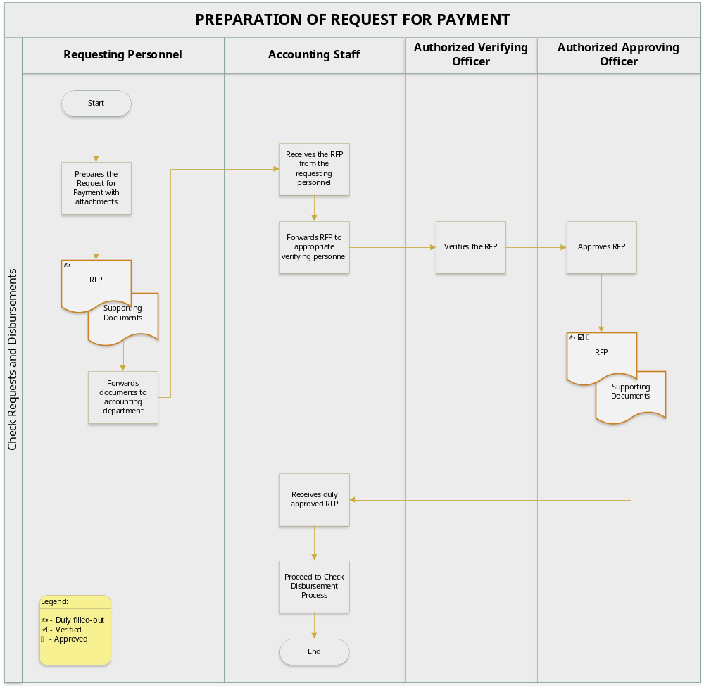

  - Accounts Payable Voucher Preparation

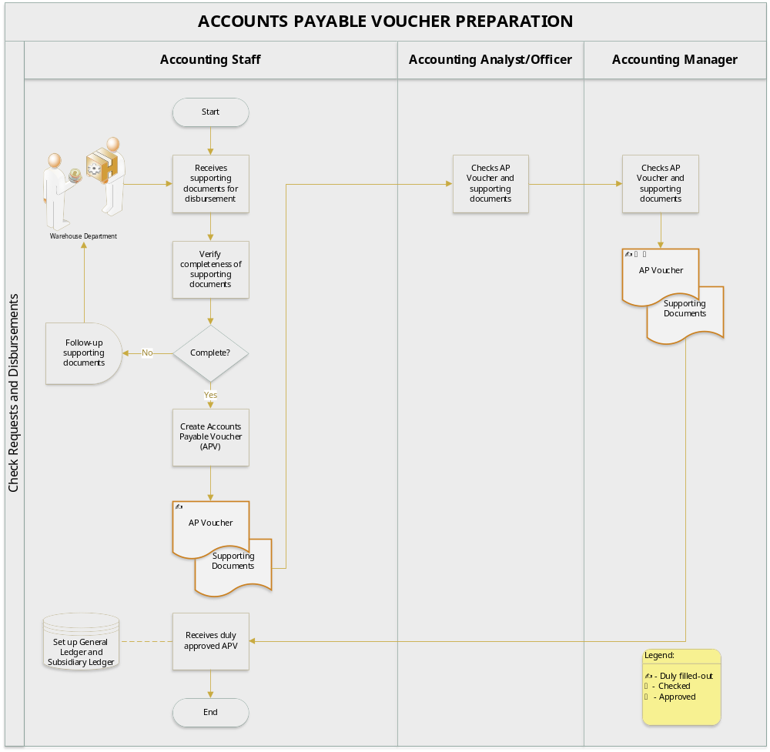

  - Disbursement Procedures

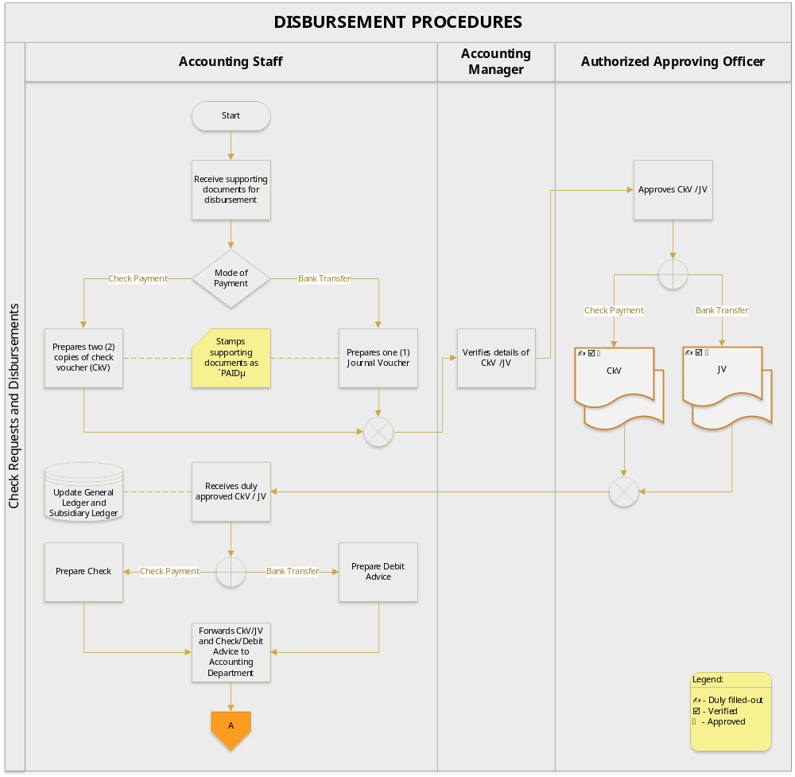

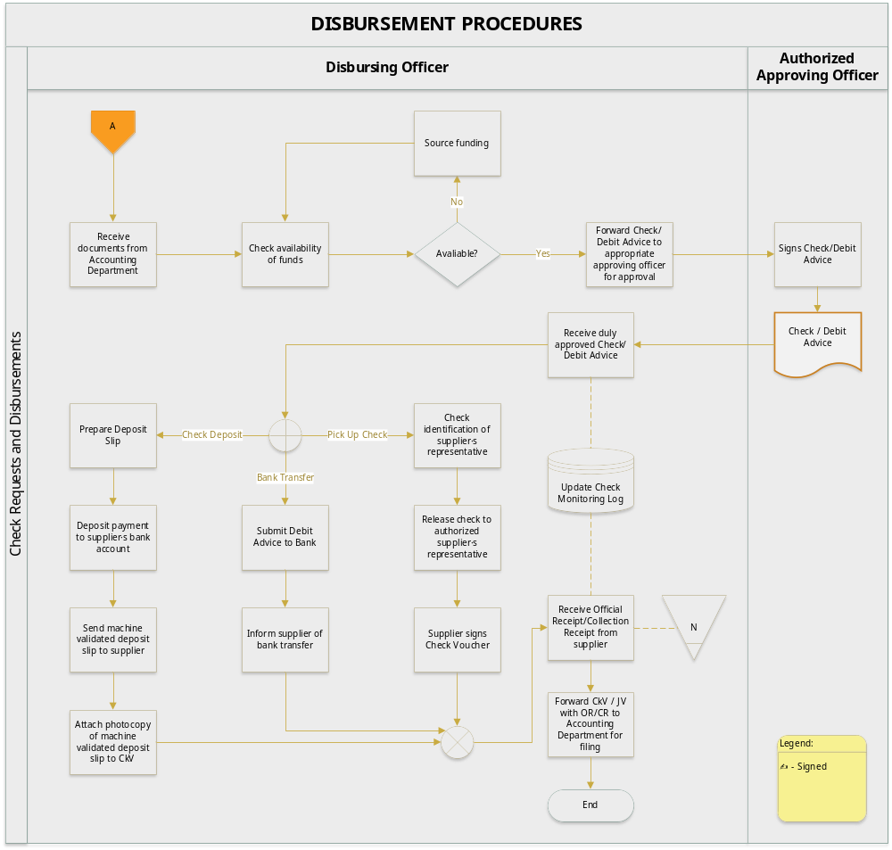

  - Disbursements of Advances to Suppliers

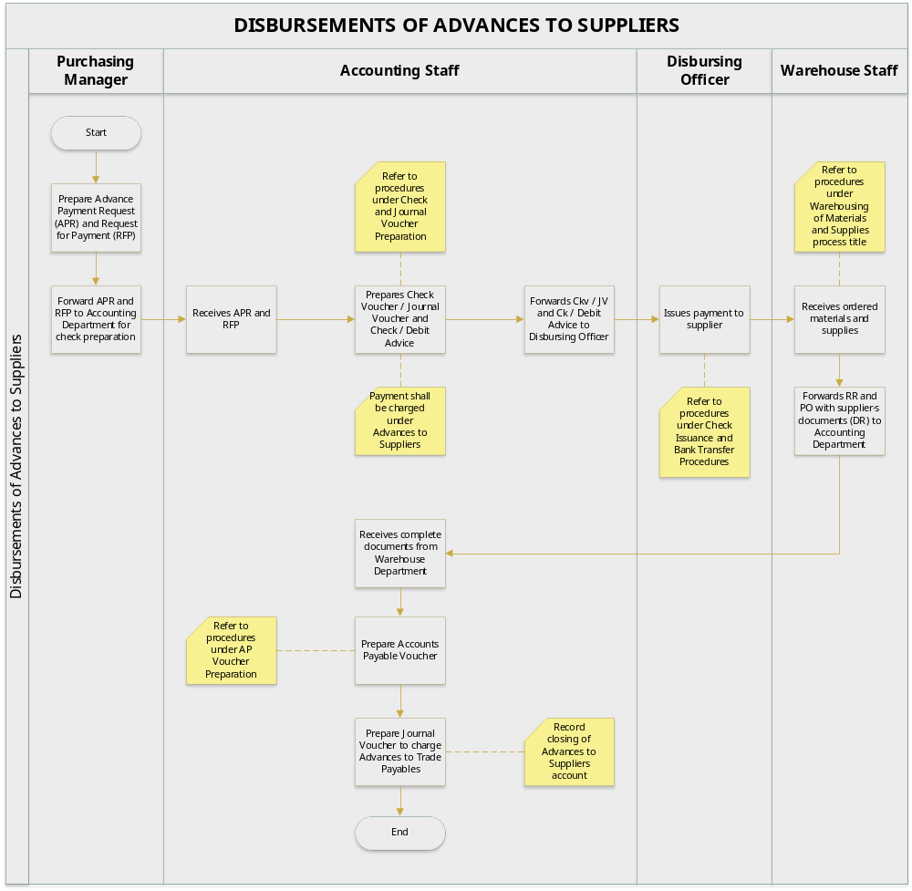
- BUSINESS FORMS

  - Request for Payment (RFP)

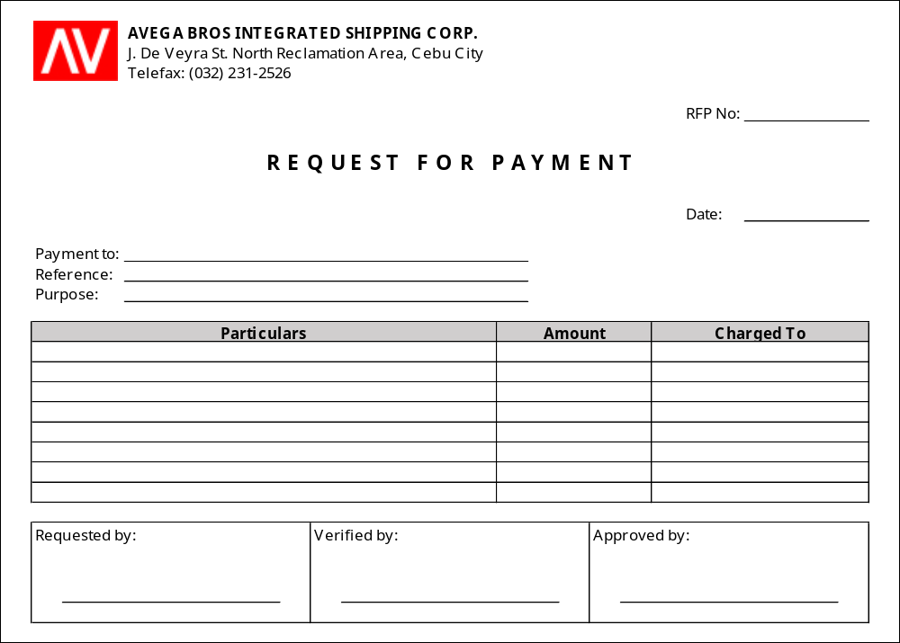

No. of Copies/color - 1
Explanation - this is prepared for disbursements requiring pre-approval of the President and other signatories especially those without supporting documents
Requested by - Requisitioner
Verified by - refer to section VI.B.3, page 6
Approved by - refer to section VI.B.3, page 6
Distribution - Accounting Department (attached to the CkV)

  - Advance Payment Request (APR)

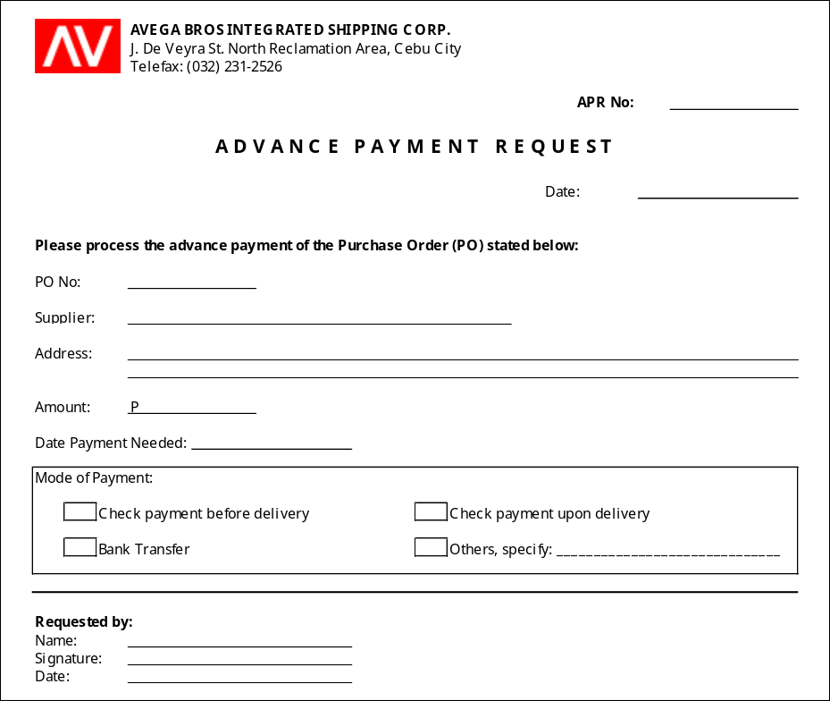

No. of Copies/color - 1
Explanation - this is prepared to authorize advance payment of purchases to suppliers
Requested by - Purchasing Manager
Distribution - Accounting Department (attached to the CkV together with RFP and other pertinent documents)

  - Accounts Payable Voucher (APV)

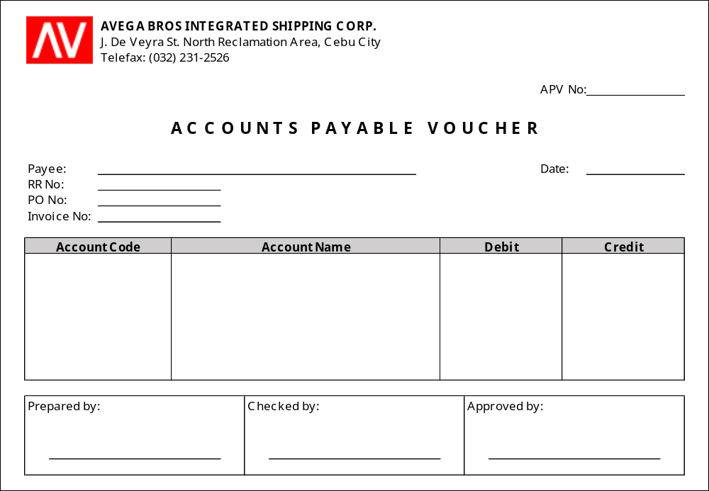

No. of Copies/color - 1
Explanation - this is prepared to record the charging of payables to specific suppliers upon completion of supporting documents (i.e. invoice, RR, PO)
Prepared by - Accounting Staff
Checked by - Accounting Analyst/Officer
Approved by - Accounting Manager
Distribution - Accounting Department (attached to the CkV)

  - Check Voucher (CkV)

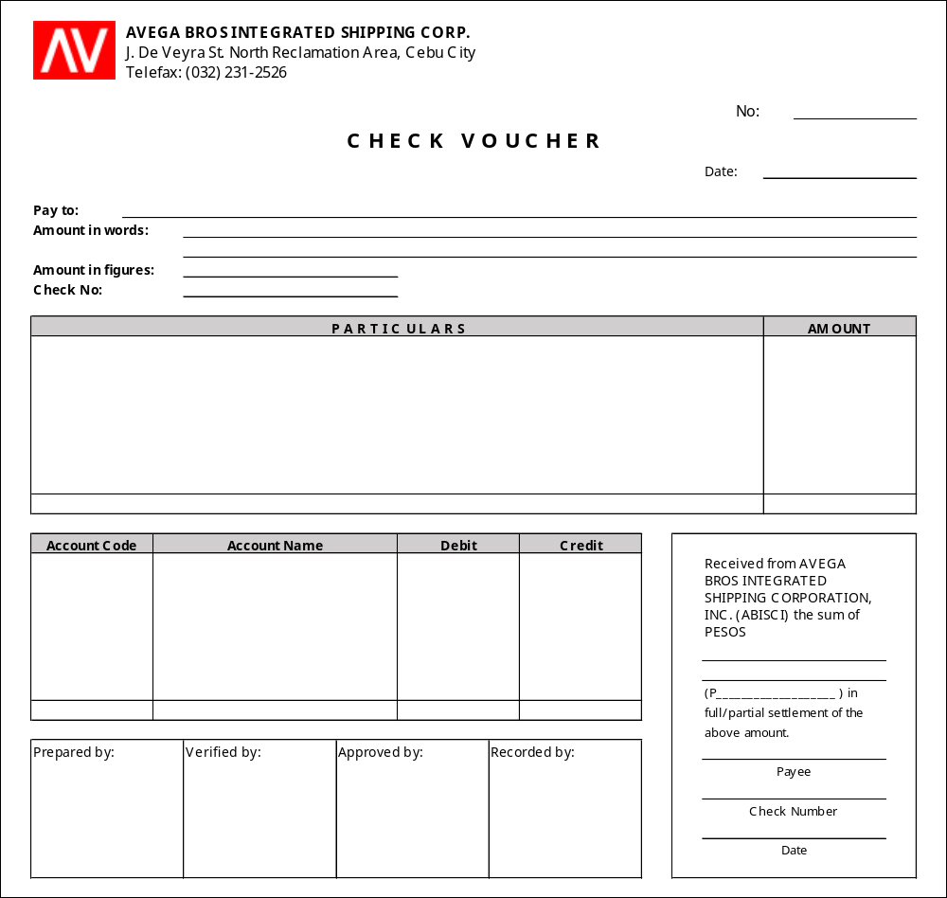

No. of Copies/color - 3
Explanation - this is prepared to document the reason for the disbursement of check
Prepared by - Accounting Staff
Verified by - Accounting Manager
Approved by - President
Distribution - CkV 1 - Accounting Department (filed together with attachments)
CkV 2 - Accounting Department (filed per payee)
CkV 3 - Accounting Department (filed numerically)

  - Disbursements Monitoring Form (Check)

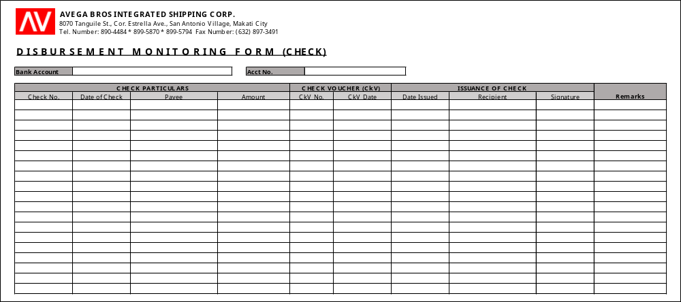

No. of Copies/color - 1
Explanation - this is prepared to monitor disbursements through the issuance of checks. This is to be updated for every receipt and issuance of checks. The recipient of the check shall acknowledge the receipt of the check by affixing his/her signature on the form.
Monitored by - Disbursing officer

  - Disbursements Monitoring Form (Bank Transfer)

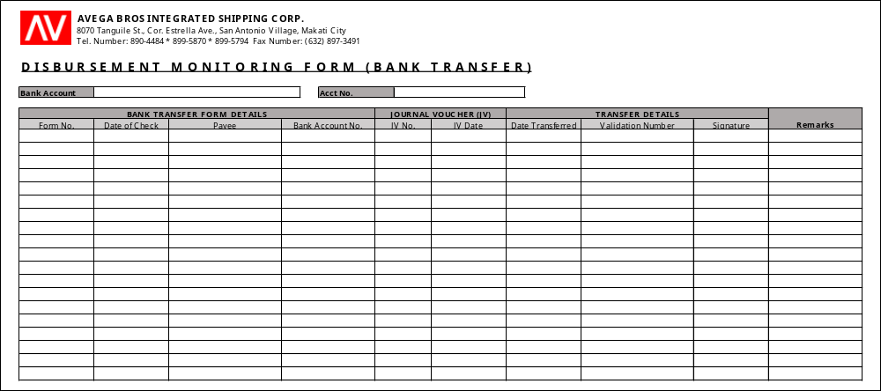

No. of Copies/color - 1
Explanation - this is prepared to monitor disbursements through the bank transfers. This is to be updated for bank transfer transactions. The details of the machine validated bank transfer form (or its equivalent) shall be indicated in the monitoring form.
Monitored by - Disbursing officer

- EFFECTIVITY

This Policies and Procedures Manual shall take effect upon approval and shall supersede any memorandum/SOP inconsistent with this Policies and Procedures Manual. Any changes to the manual shall comply with the policies and procedures indicated in the process title “Amendment of Manual”.

ANNEX

ANNEX A
Accounts Payable Voucher Documents Checklist

